# EECS 368 Final Project Proposal

Our group’s final project will be an online math game for kids learning basic addition, subtraction, multiplication, and division. The project will utilize JavaScript for the functions and html manipulation, HTML to display the game, and SQL and PHP for teachers to store pre-made problems and student answers. Our group is composed of Computer Science majors of varying levels. Half of us have SQL abilities and all of us have been exposed to JavaScript and HTML. This report will go over the goals of the project, division of labor, and the timeline to carry out the project.

## Details

As stated above this project will be an online math game. There will be a tab for randomly generated math problems, a tab for teachers to create math quizzes and view student results, and a tab for students to take the quizzes from their teachers. The game itself will be interactive and geared towards children. We will do this by having a visual basketball game.

There are tons of math games out there that do the math we are providing in a similar simple game format. Our idea is not novel, but we think it will be a way to demonstrate our knowledge of JavaScript and HTML, two languages that have been covered heavily in 368. It also will give us the opportunity of marrying the two languages and learning more about how they can interact. The thing that may be different (however, we doubt it) is that we offer a game that allows the student to practice but also to take tests created by the teacher. The goal was to combine the fun math atmosphere with a way for teachers to quiz their students and view what problems need to be covered more. Although there are similar types of games out there to accidentally plagiarize, we will not use their source code in any way. If we run into needing help we will consult the W3schools website instead of an already created game.

Because we are utilizing the resources given through KU EECS, the literal cost of the project will be nothing. However, we will be dedicating quite a bit of time to the project that could be spent elsewhere. Altogether we believe the project will take at least a full day’s work per person and then another two day’s work to combine and solve problems that should arise. During the singular person’s full day’s work at the end of creating their individual page they will test it. The server side people will test by throwing various data into the tables and checking the tables through the database site for accuracy. The people generating the game will test by actually playing the game itself. Finally another test will occur at the end of production. This test will have us do a full sweep of the site in which we will interact with every button, drag drop, field etc. The end goal of this test is to have the program work seamlessly together with no bugs. (To see the division of labor and timeline, refer below).

The game format will have a math problem displayed on a basketball and there will be a variety of hoops with a variety of answers. The student must then pick a basket to “shoot” the question into. If correct, the scoreboard will increase and a new problem will be displayed. If incorrect, a new problem will be displayed and a “You missed box” will show up briefly.

There will be three main windows for the website game: randomly generated questions meant for practice, teacher access, and student access. The randomly generated questions page allows the choice for subtraction, addition, multiplication, or division practice. The page will have a done button which can be pressed at any time. Upon the done button being pressed the screen will change to a review tab which will print how many questions were answered correctly out of the total given.

The teacher access page will give the teacher the ability to create a login and then login. Once logged in, the teacher may create any type of addition, subtraction, multiplication, or division quiz. The teacher will also be given a randomly generated code to give to their students for access. Once a student has taken the quiz their score will be accessible by the teacher. All this information will be stored in SQL tables.

The student access page will have the student enter the access code and a student id then will direct them to the quiz. The page will have a done button which upon completion will store the student’s results into a table for the teacher to view.

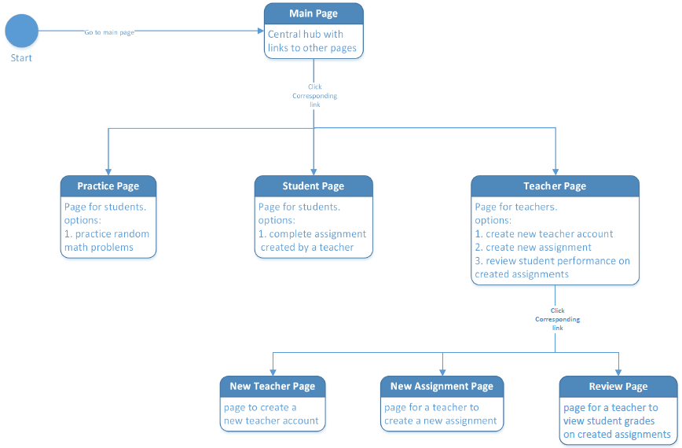

## Division of Labor

Josiah will focus on creating the student access page and Kate will do the teacher access page. Because the SQL tables will be shared for these pages, we will also be working together to make sure they interact well on both ends. Hamza will be doing the frontend of the game and Andrew will be doing the backend of the game itself. Hamza and Andrew will also be a mini-team to make sure their files interact correctly. Nearing the end of the project everyone will get together and combine the files together. To see what each person will be doing specifically, see the details section and timeline.

## Timeline

|  |  |  |  |  |
| --- | --- | --- | --- | --- |
| **Task** | **Details** | **Person Assigned to Task** | **Estimated hours** | **Desired finish date** |
| Teacher page | Page to log on or create a log in | Kate | 1 | 23-Apr |
|  | Page to create quizzes | Kate | 3 | 23-Apr |
|  | Page to review student answers and success | Kate | 3 | 23-Apr |
|  | CSS the pages | Kate | 1.5 | 23-Apr |
| Student Page | Page to log in then take an exam based on an access code | Josiah | 4 | 23-Apr |
| Practice Page | Random problem generator (backend) | Andrew | 1 | 23-Apr |
|  | GUI elements (frontend) | Hamza | 5 | 23-Apr |
|  | Combine frontend and backend | Hamza, Andrew | 3 | 23-Apr |
| Combine | Incorporate game into student quiz | Josiah, Hamza, Andrew | 4 | 30-Apr |
| everything | Create a frontend that has buttons directing to pages | Anyone | 0.5 | 30-Apr |
| Problems | Anything that should arise | Anyone | 4 | Anytime |